**Lab 9: Disassembling C on Windows**

**Course Name**: Malware Analysis and Reverse Engineering (IAM302)

**Student Name**: Nguyễn Trần Vinh – SE160258

**Instructor Name**: Mai Hoàng Đỉnh

**Lab Due Date**: 15/2/2023

**Purpose**

You will write a small C programs, compile it, and examine it in the IDA Pro disassembler to learn what it looks like in assembly language.

**What You Need**

* A Windows machine, real or virtual. I used Windows 8.
* Visual Studio Express, which you installed in a previous project.
* IDA Pro Free, which you installed in a previous project.

**Starting Visual Studio Express**

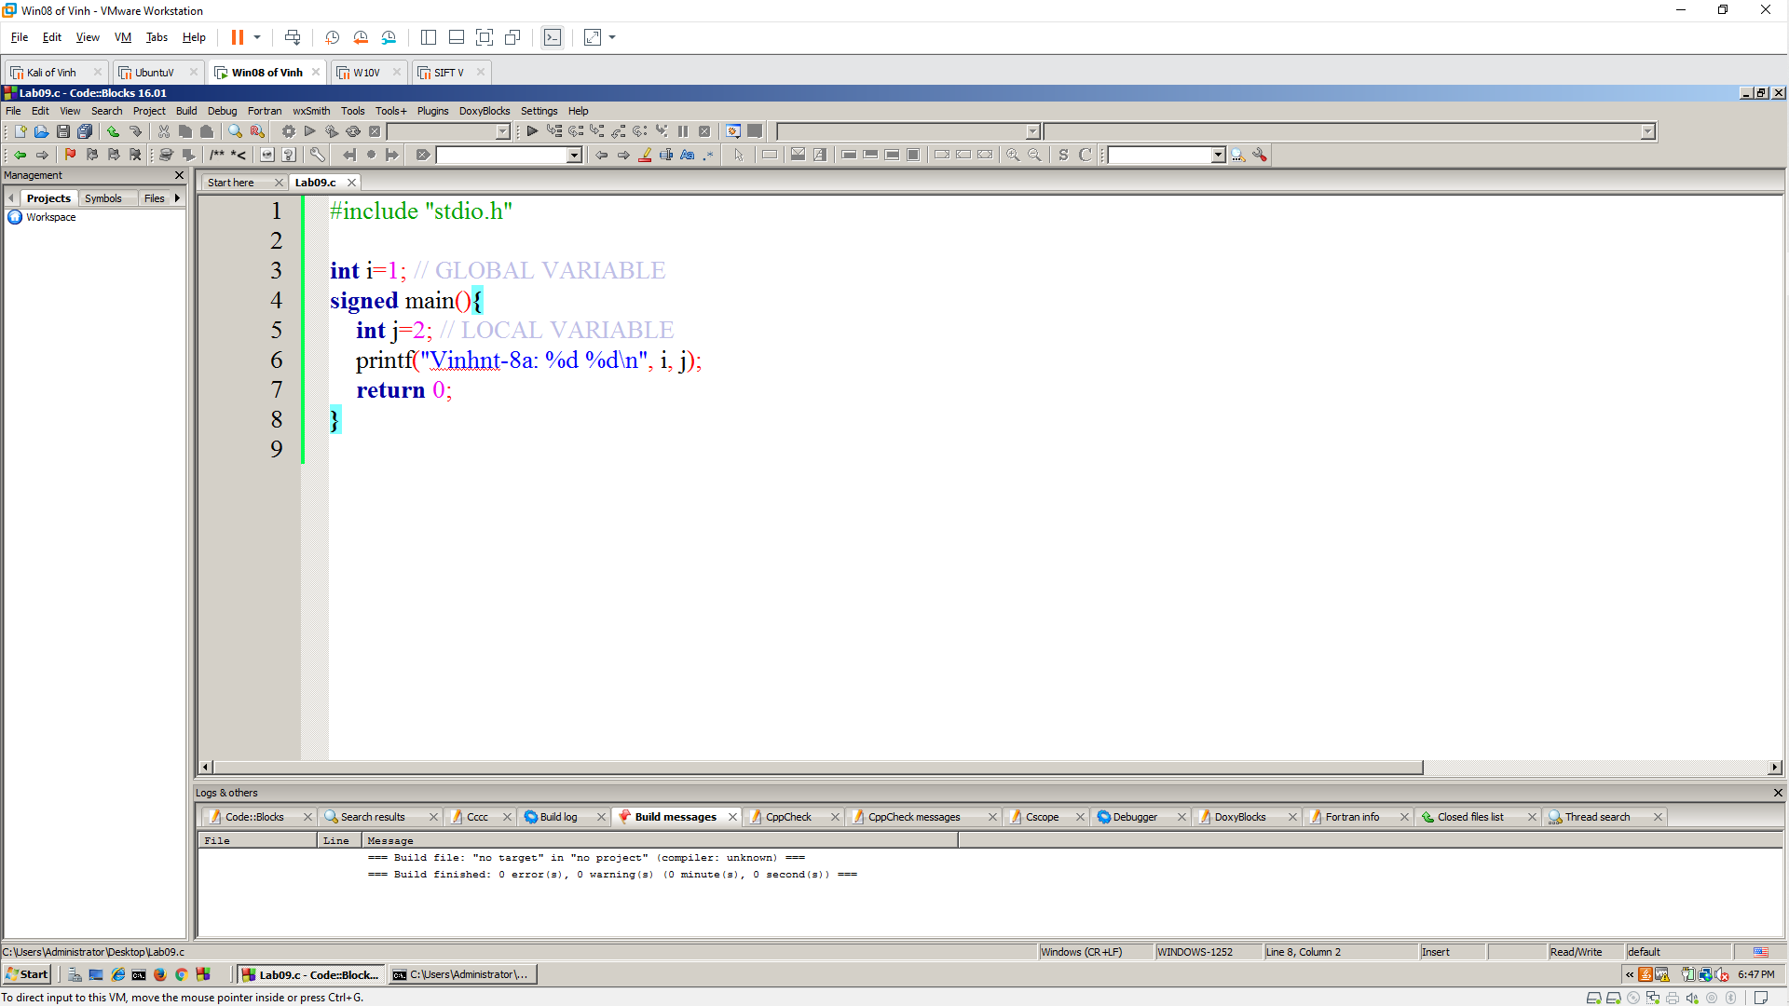

**Build and Run**

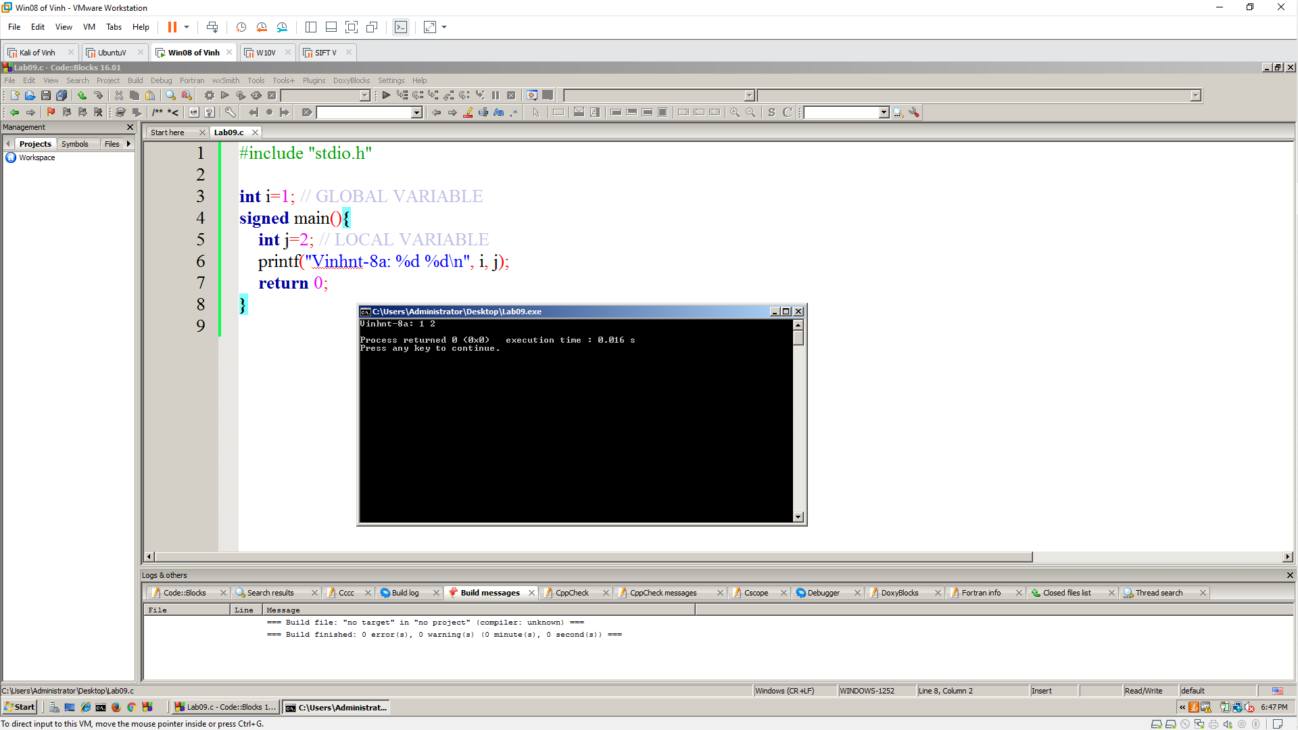

**Disassembling the EXE**

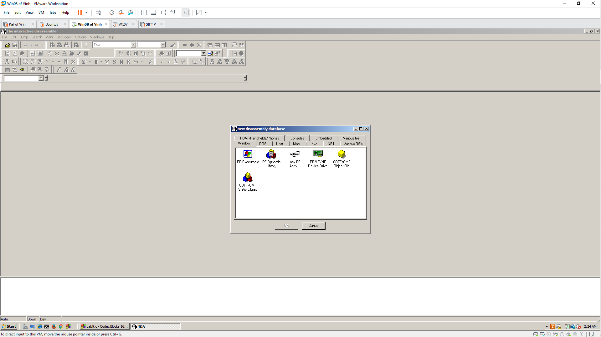

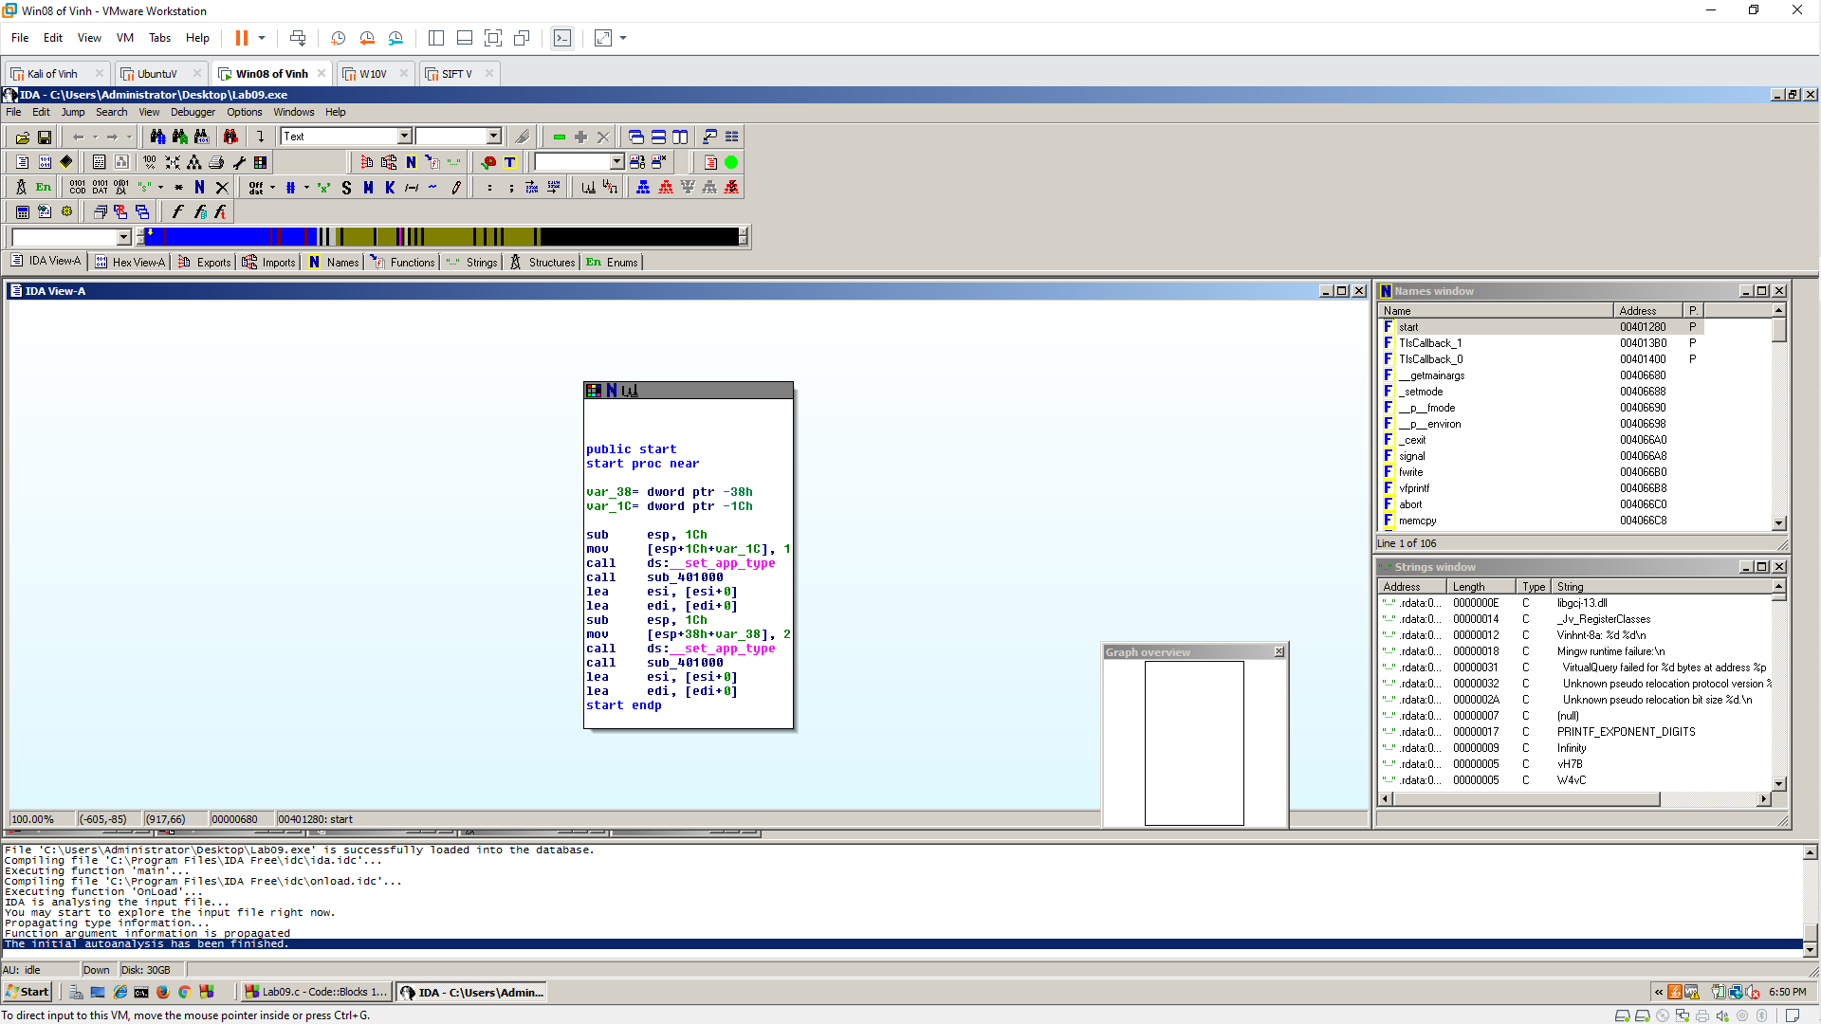

**Strings window**

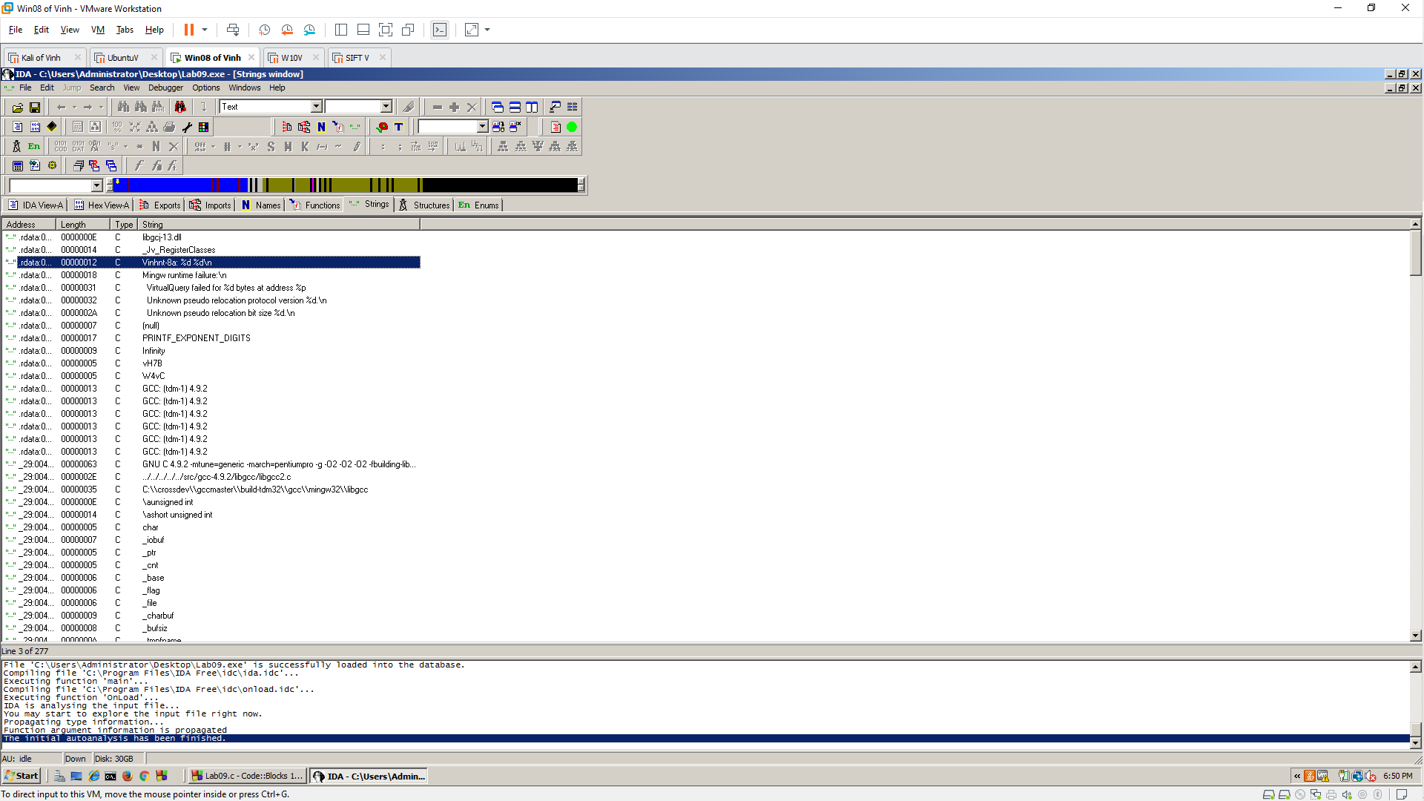

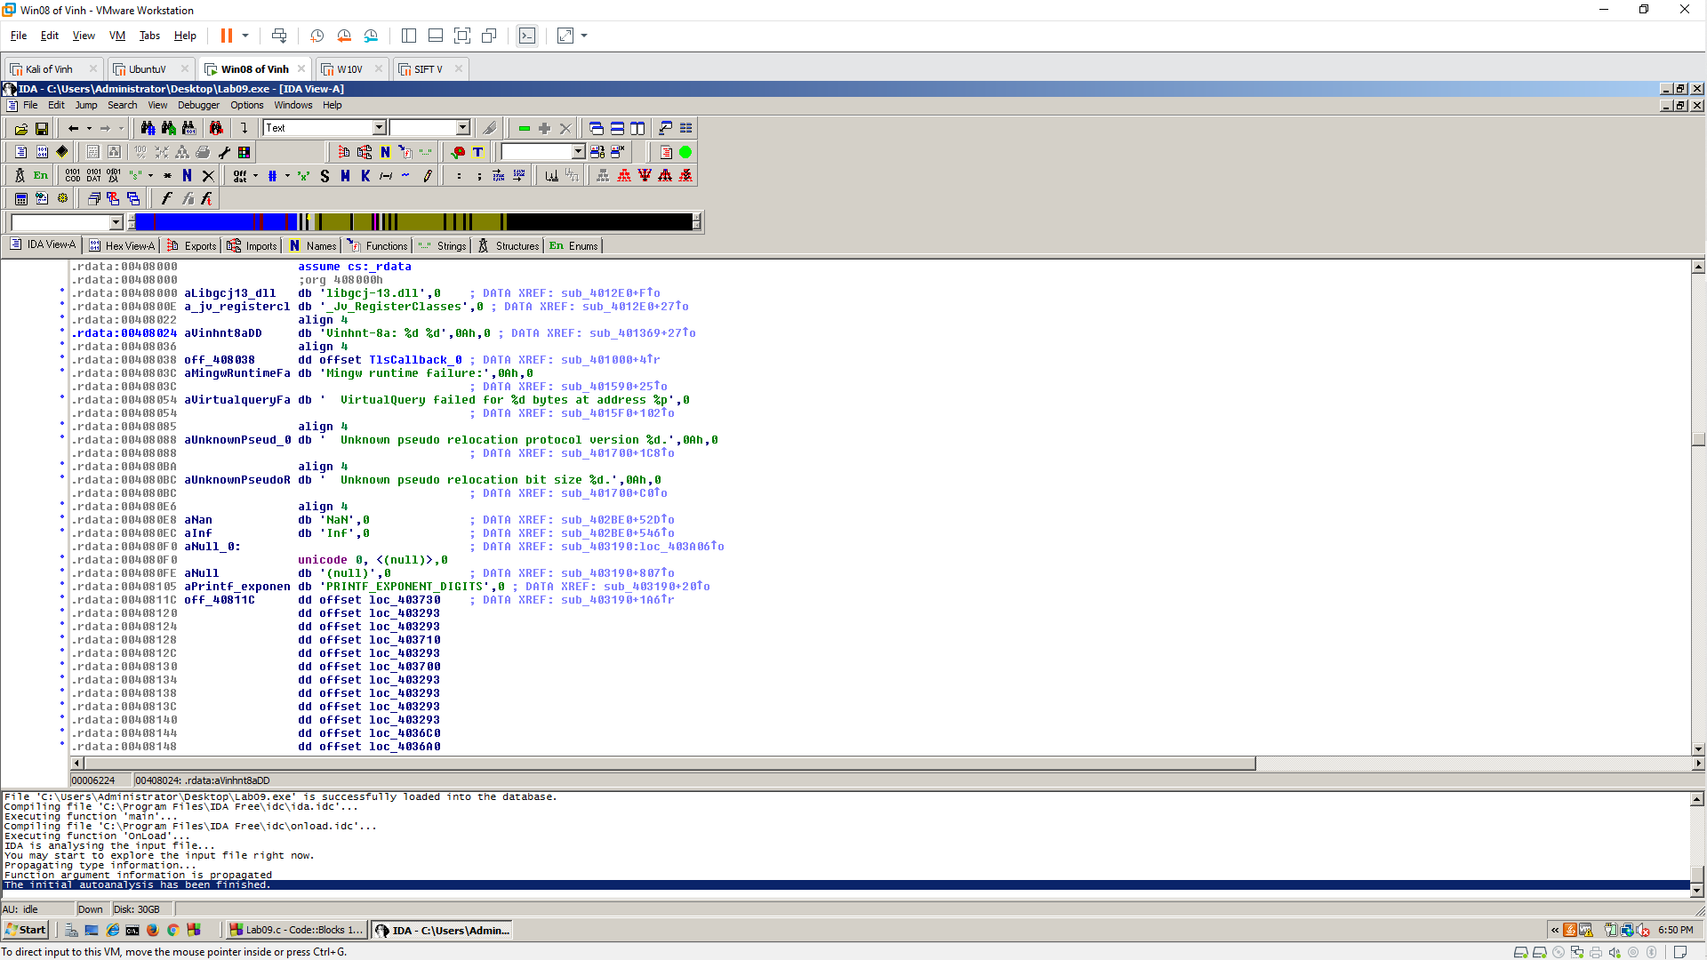

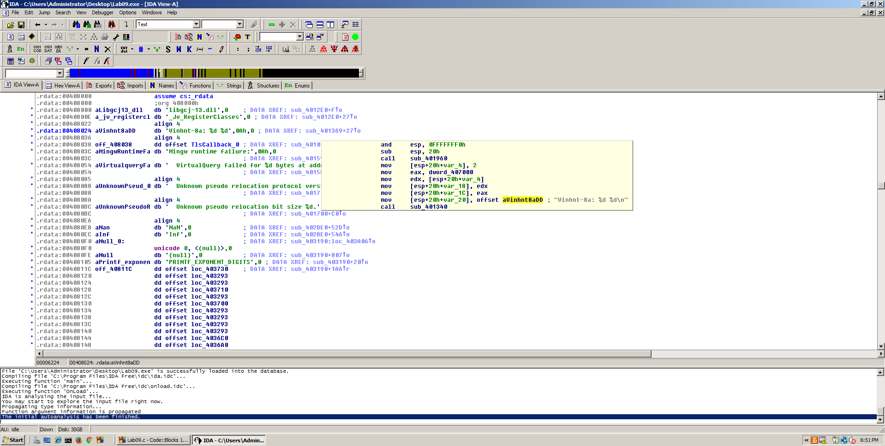

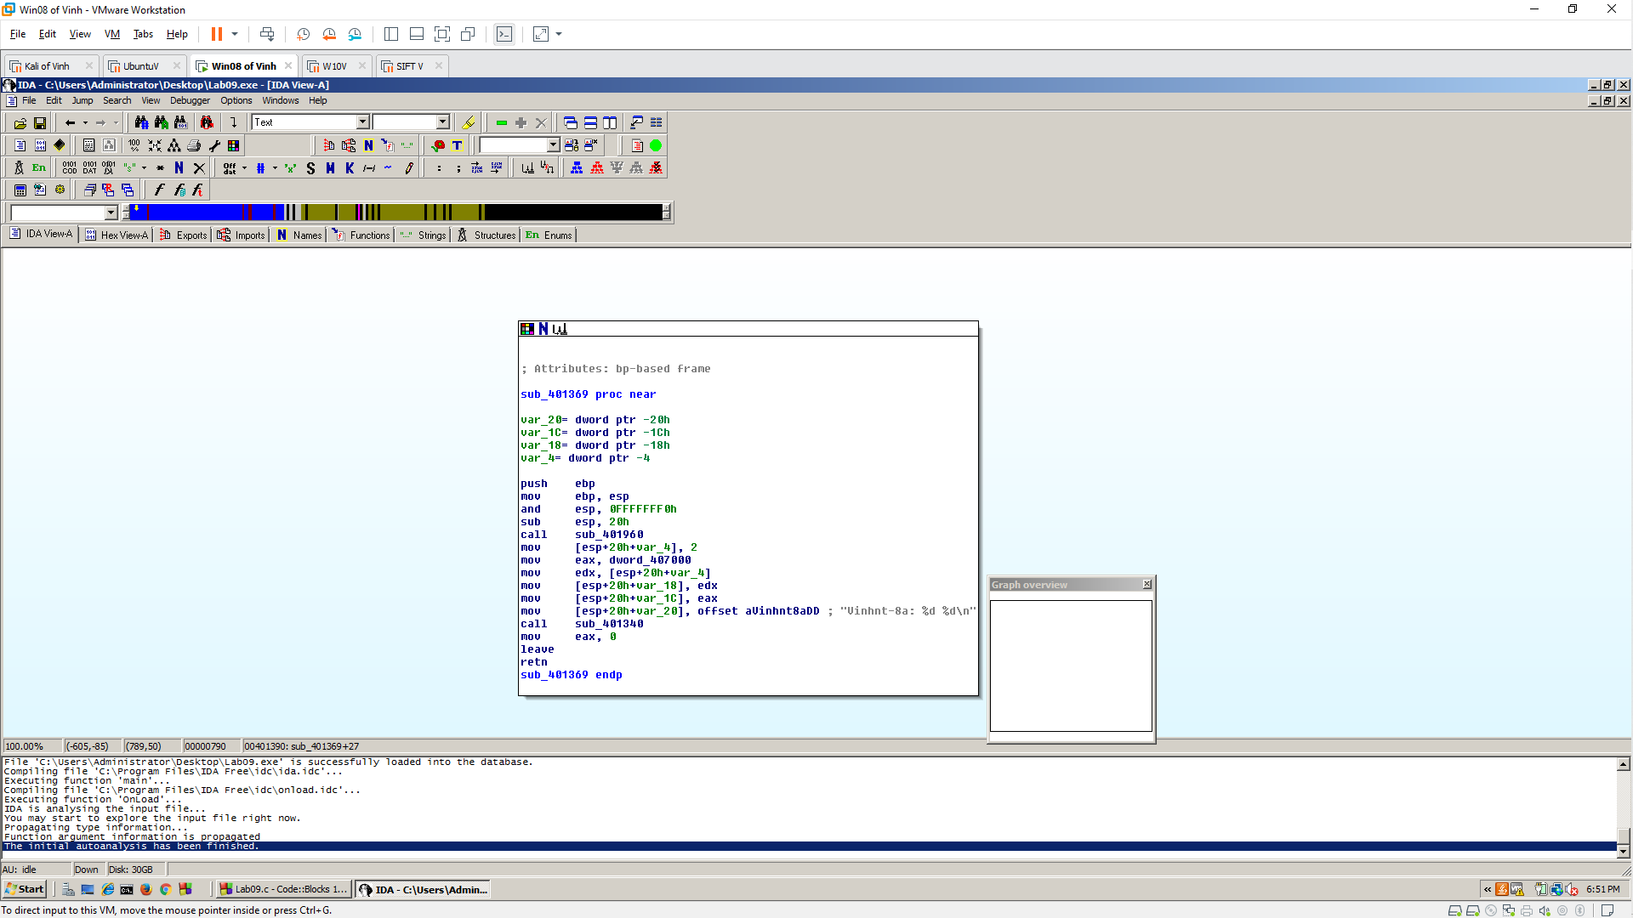

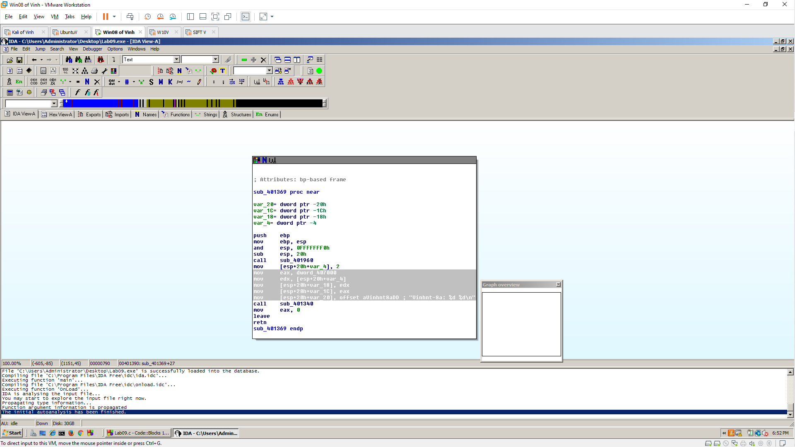

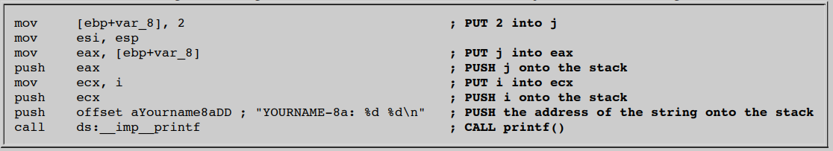

**CHALLENGE: 10 Pts. Extra Credit**

